Project Design Phase-I
Solution Architecture

Date | 25 October 2026
Team ID | EN25CS3090101
Project Name | EV Market Performance and Insights
Maximum Marks | 4 Marks

Solution Architecture:
Solution architecture is a complex process – with many sub-processes – that bridges the gap between business problems and technology solutions. Its goals are to:
- Find the best tech solution to solve existing business problems.
- Describe the structure, characteristics, behavior, and other aspects of the software to project stakeholders.
- Define features, development phases, and solution requirements.
- Provide specifications according to which the solution is defined, managed, and delivered.

Sample Solution Architecture Diagram:
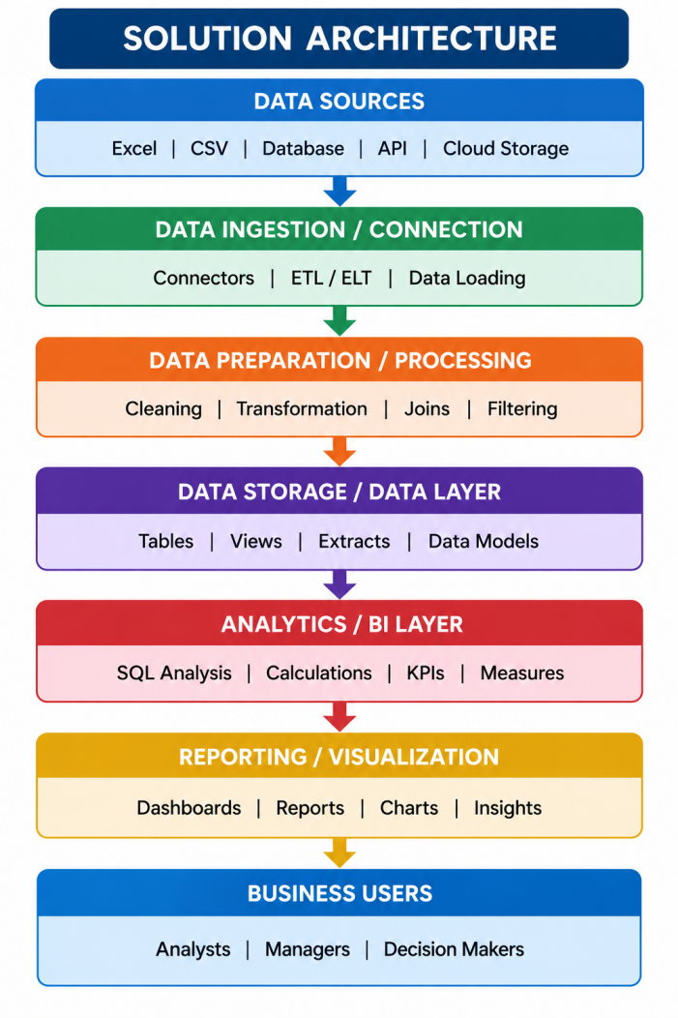

Component Description Table
Component Name | Description / Role in Architecture | Technology Used

